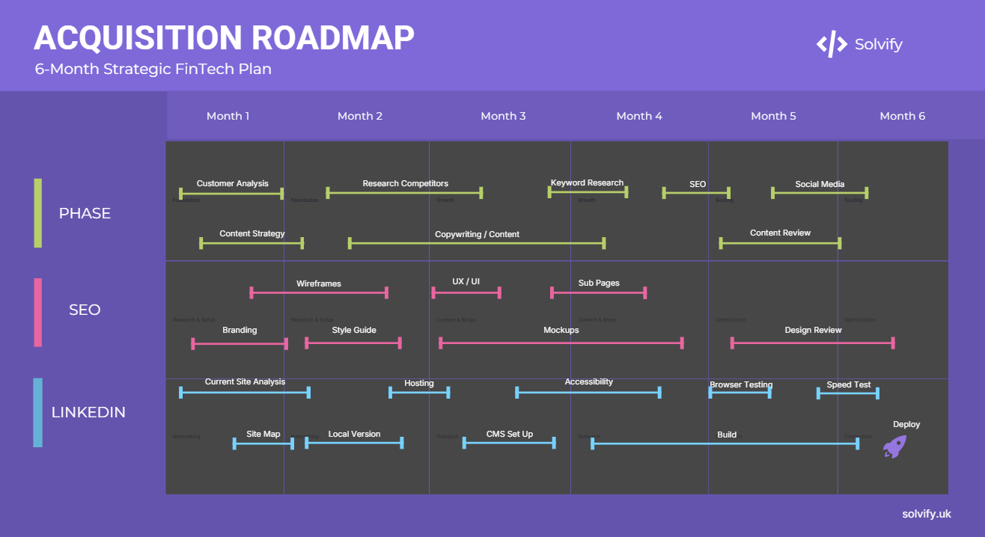
6-Month Client Acquisition Roadmap: FinTech Software Engineer (Freelance)
Overall Goal: To consistently attract and convert small FinTech startups into paying clients for Custom Backend Development, API Integration, FinTech System Modernization, and Full-Stack Development.

Phase 1: Foundation & Visibility (Months 1-2)
Focus: Optimizing my online presence and initiating outreach.
1. SEO Plan: Targeting "FinTech Freelancer" & Service Keywords
- Goal: Identify and strategically incorporate high-potential keywords to improve the visibility of my personal brand in search engine results.
- Actionable Implementation – Keyword Research
  - Core Identity Keywords: These are the most important and should appear naturally throughout the webpage.
    - Software Engineer
    - Full Stack Developer
    - Backend Engineer
    - Java Developer
    - JavaScript Developer
    - Python Developer
    - API integration specialist
  - Specialisation & Technology Keywords: These highlight specific skills and experience
    - Spring Boot
    - Node.js
    - SQL
    - RESTful APIs
    - Financial Technology (FinTech)
    - Banking Software
    - Workflow Automation
    - Loan Approval Systems
    - Microservices
    - Cloud Technologies (AWS, Azure, GCP
  - Role & Industry Keywords: these describe experience and the sectors worked in
    - Atom Bank
    - HSBC
    - FDM Group
    - IT Consultant
    - Development Engineer
    - Analyst Developer
  - Advocacy & Soft Skills Keyword: these highlight unique value and community involvement
    - Women in Tech
    - STEM Ambassador
    - Tech Inclusion
    - Mentorship
    - Cross-functional Collaboration

- Actions:
  - Website On-Page SEO:
    - Implement Meta Title/Description (Crucial for SEO): make the website more visible on the internet
    - Keyword Integration: Review all website pages (Homepage, Services, Case Studies, About, Process) to ensure natural integration of the above keywords within headings (H1, H2, H3), body text, and image alt tags.
    - Descriptive URLs: ensure that the domain used is clear.
  - Analytics Setup: Use Google Analytics to track traffic, popular pages, and conversion rates.
  - Initial Backlinks (Early Stage):
    - Ensure my LinkedIn profile links to my website.
    - List my website on any relevant developer directories (Crunchbase, Clutch etc)
    - List projects on GitHub
2. LinkedIn Engagement Plan
- Goal: Build a targeted network, establish thought leadership, and drive traffic to my website.
- Actions:
  - Profile Optimization (Already Done): Ensure my "About" section, headline, and experience are fully updated with keywords and a client-centric message. Include my website link prominently.
  - Targeted Connection Requests:
    - Identify decision-makers at small FinTech startups: Founders, CTOs, Engineering Leads, Product Managers in my target geographic area (e.g., London).
    - Send personalized connection requests referencing shared interests, industry, or specific problems I solve (e.g., " Saw you're building in cloud-native banking. I specialize in microservices and automated compliance. Would love to connect.").
    - Aim for 10-15 targeted connections per week initially.
  - Content Sharing:
    - Share my Website Content: Post links to my new website's Services, Case Studies, and About pages. Frame it with a question or a problem statement. (e.g., "Are FinTech integration challenges holding your startup back? Check out how I've helped clients overcome them...[present a link to case study page on website]").
    - Curate Industry News: Share relevant FinTech news, trends, and articles, adding my unique perspective or a question to spark discussion.
    - Engage with Target Audience's Posts: Comment thoughtfully on posts from my target connections or FinTech influencers. Note: Don't just like – add value.
  - "Book a Call" CTA: Integrate my SimplyMeet.me link into my LinkedIn profile (contact info/bio) and occasionally share it in posts or comments when relevant.

Phase 2: Growth & Nurturing (Months 3-4)
Focus: Deepening engagement, demonstrating expertise, and direct outreach.
1. SEO Plan: Content & Authority Building
- Goal: Improve search rankings further through valuable content and expand keyword reach.
- Actions:
  - Blog Content (Start 1-2 articles/month):
    - Write articles directly addressing client pain points using my services as solutions. (e.g., "5 Ways Robust APIs Can Accelerate Your FinTech Product Launch," "Modernizing Legacy Systems in Banking: A Startup's Guide").
    - Integrate long-tail keywords.
    - Internally link to my Services & Case Studies pages.
  - Backlink Building (Strategic):
    - Guest posting on FinTech industry blogs or developer community sites.
    - Participating in podcasts or webinars related to FinTech development (leverage my "Unlock Her Tech" experience here).
    - Reach out to relevant FinTech news sites or incubators for potential mentions.
2. LinkedIn Engagement Plan
- Goal: Position myself as a go-to expert and generate qualified leads.
- Actions:
  - Thought Leadership Posts: Share original insights, short tutorials, or opinions on FinTech development trends, challenges, and solutions. (e.g., "My take on the future of embedded finance backend architecture," "Common pitfalls in FinTech API development").
  - Direct Messaging (Targeted Outreach):
    - For 3-5 high-potential connections per week (after I've engaged with their content or they've viewed my profile), send a personalized message.
    - Example: "Hi Olivia, I noticed your work on your company’s recent migration to a microservices architecture. As a FinTech backend specialist, I'm always interested in how legacy banking systems handle high-concurrency transaction volumes. I've recently helped clients with reducing API latency during peak traffic surges. If you ever need support with optimizing distributed database performance, I'd be happy to share some insights on a quick call."
  - LinkedIn Articles/Newsletters: Consider writing longer-form articles on LinkedIn to showcase deeper expertise.
  - Engage with Company Pages: Follow and engage with the LinkedIn pages of target FinTech startups.

Phase 3: Conversion & Scaling (Months 5-6)
Focus: Optimizing conversion funnels, formalizing proposals, and scaling efforts.
1. SEO Plan: Monitoring & Refinement
- Goal: Maintain and improve rankings, convert organic traffic, and refine strategy based on data.
- Actions:
  - Monitor Analytics: Analyse website traffic, keyword performance (Google Search Console), and conversion rates (CTA clicks, form submissions, booking page visits).
  - A/B Testing: Test different headlines, CTAs, or page layouts to optimize conversion rates.
  - Technical SEO Review: Check site speed, mobile-friendliness, and crawlability regularly.
  - Update Content: Refresh blog posts and case studies.
2. LinkedIn Engagement Plan
- Goal: Convert active leads into consultations, projects and expand referral network.
- Actions:
  - Leverage Recommendations: Request recommendations from past colleagues or clients (especially those for whom I've done freelance work).
  - Host a LinkedIn Live/Webinar (Optional): Present on a specific FinTech development challenge/solution, establishing myself as a leading voice.
  - Ask for Referrals: After successful projects, ask satisfied clients if they know anyone else who could benefit from my services.
  - Refine Outreach Messages: Continuously improve my direct messaging based on what yields the best response rates.
  - Track Lead Sources: Ask new clients how they found me to refine my focus.

Crucial Overarching Tool:
- CRM/Lead Tracking System: Even a simple spreadsheet initially to track:
  - Leads (Company, Contact Name, Role)
  - Source (LinkedIn, Google Search, Referral)
  - Outreach Date & Method
  - Response & Follow-up
  - Status (Qualified, Discovery Call, Proposal Sent, Closed Won/Lost)

